1. Create the DEPT table based on the following table instance chart.

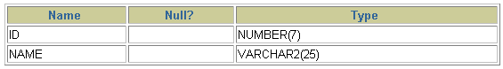

--🡪 CREATE TABLE dept

(id NUMBER(7),

name VARCHAR2(25));

describe dept;

1. Populate the DEPT table with data from the DEPARTMENTS table. Include only columns that you need.

--🡪 **INSERT INTO dept**

**SELECT department_id, department_name**

**FROM departments;**

3. Create the EMP table based on the following table instance chart. Confirm that the table is created.

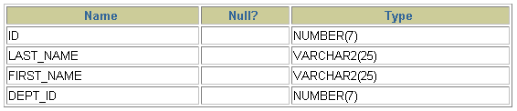

-----🡪 **CREATE TABLE emp**

**(id NUMBER(7),**

**last_name VARCHAR2(25),**

**first_name VARCHAR2(25),**

**dept_id NUMBER(7));**

**DESCRIBE emp**

4. Create the EMPLOYEES2 table based on the structure of the EMPLOYEES table. Include only the EMPLOYEE_ID, FIRST_NAME, LAST_NAME, SALARY, and DEPARTMENT_ID columns. Name the columns in your new table ID, FIRST_NAME, LAST_NAME, SALARY , and DEPT_ID, respectively.

--🡪 **CREATE TABLE employees2 AS**

**SELECT employee_id id, first_name, last_name, salary,**

**department_id dept_id**

**FROM employees;**

5. Drop the EMP table.

**-🡪 DROP TABLE emp;**